Component Based Systems
AsteroidsFX

Student Name: Oliver Thomsen
Exam Number: 4140042
GitHub User: Olithomsen
GitHub Repo: https://github.com/Olithomsen/Asteroids
Demo: https://youtu.be/T7N9Ujm_5sY

Contents
Abstract 3
Introduction 3
Requirements 4
IGamePluginService 4
IEntityProcessingService 4
IPostEntityProcessingService 4
Functional Requirements 4
Non-Functional Requirements 5
Analysis 5
Problem Domain 6
Component Identification 6
Service Interface Model 6
Use Cases 7
Design 7
Module Architecture 8
Service Provider Architecture 8
JPMS Module Declarations 9
Spring Integration 9
Component Contracts Summary 9
Implementation 10
Component Registration via ServiceLoader 11
Enforcing Dependencies and Encapsulation 11
Component Implementations 11
Test 12
Discussion 12
Conclusion 12
References 12

Abstract
The central problem addressed in this report is runtime composability in a component-based game system. In a conventional game architecture, adding or removing a game element requires modifications in the game loop and recompiling dependent modules. This creates tight coupling that makes the system fragile and difficult to extend.
AsteroidsFX is an implementation of the classic Asteroids arcade game that solves this problem through component-oriented programming backed by three complementary technologies which are the Java Platform Module System (JPMS), the ServiceLoader API and the spring framework. Each game element is implemented as an independent module that declares its capabilities through service provider interfaces. The orchestrator discovers and assembles these modules at runtime without any compile-time knowledge of their implementations. A component can be added or removed from the system purely by modifying the module path with no changes to any existing code.

Introduction
Component-oriented programming (COP) is a software development paradigm in which the systems are built from self-contained, independently deployable components, that interact through well-defined interfaces. Unlike object-oriented programming, which focuses on modelling entities, COP focuses on composition of executable components and the contracts between them. A key property of a well-designed component system is that the components can be substituted or extended without modifying or recompiling the rest of the system.
The game presents a concrete and observable domain where a player-controlled ship navigates a field of asteroids and enemies, firing projectiles that cause collisions and state changes. The system handles player control, enemy behavior, projectile lifecycles, asteroid movement, and collision detection via distinct, decoupled component modules.
The system is structured around three complementary technologies. The Java Platform Module System (JPMS) enforces strong module boundaries and explicit dependency declarations at the language level. The Java ServiceLoader API enables runtime discovery of component implementations without central registration. Spring Framework provides dependency injection for the core orchestration layer. These technologies realize a component model in which the orchestrator assembles a running game from independently developed and deployed modules.
This report describes the requirements, analysis, design, implementation, and testing of this architecture. The game logic serves as the vehicle for demonstrating component-oriented principles. The architectural decisions and their consequences are the primary subject of the report.

Requirements
The system defines three service provider interfaces (SPIs) that form the contract between the orchestrator and all component modules. These interfaces are the primary architectural artifacts of the system and govern how components register themselves, how they participate in the game loop and how post-frame interactions are resolved.

IGamePluginService
This interface is responsible for component lifecycle management. Any module that needs to initialize or clean up game state must implement this interface.
Pre-condition: The gameData and world parameters are not null and the world may already contain other plugins’ entities.
Post-condition (Start): All plugin entities have been added to World and plugin-specific states are initialized.
Post-condition (Stop): All plugin entities have been removed from World and the plugin-specific resources are released.

IEntityProcessingService
This interface is responsible for updating the entity state on every game-loop frame. Any module that manages moving or stateful entities must implement this interface.
Pre-condition: gameData.getDeltaTime() > 0 and world is not null and contains entities to process.
Post-condition: Entity positions, velocities and rotations are updated. New entities may be added and out-of-bounds entities may be removed. No collision logic is applied.

IPostEntityProcessingService
This interface is responsible for inter-entity interactions that must run after all the entity processors have completed for the frame. Collision detection is its only implementation in this system.
Pre-condition: All IEntityProcessingService calls have completed and the entity positions are final for the current frame.
Post-condition: Collisions are detected and handled. Hit entities have their health reduced, destroyed entities are removed and asteroids marked for splitting are split.

Functional Requirements
ID | Description
P-1 | The game must have a player component.
P-2 | The player must be controllable via keyboard input.
P-3 | The player must have a health system and be removed from the game when health reaches zero.
P-4 | The player must be able to fire bullets that can damage enemies and asteroids.
E-1 | The game must have an enemy component.
E-2 | Enemies must spawn at a fixed interval and move autonomously around the world.
E-3 | Enemies must have a health system and be removed from the game when the health reaches zero.
E-4 | A collision between enemy and the player must reduce players health.
A-1 | The game must have an asteroid component.
A-2 | Asteroids must spawn at a fixed interval and move in a random direction.
A-3 | When an asteroid takes damage, it must split into two smaller asteroids.
A-4 | A collision between an asteroid and the player must reduce the players health.
WB-1 | The game must have a weapon component responsible for creating and firing bullets.
WB-2 | Bullets must travel in the direction the firing entity is facing at a fixed speed.
WB-3 | Bullets must be removed from the game world when they leave the screen boundaries.
WB-4 | The weapon component must be usable by both the player and enemy components through a shared service interface.
C-1 | The game must have a collision component that resolves interactions between all types of entities.
Table 1 Functional Requirements

Non-Functional Requirements
ID | Description
NF-1 | Player, Enemy, Asteroid, Weapon and Collision components must implement service provider interfaces, allowing them to be updated or removed without recompilation of any other component.
NF-2 | A component must be removable from the module path at build time without causing compilation or startup failures in any remaining components.
NF-3 | The application must follow a layered architecture enforced by the Java Platform Module System with no circular dependencies between modules.
NF-4 | The application must incorporate the outcomes of all java labs: JPMS module declarations, ServiceLoader-based discovery, Spring dependency injection and automated unit testing.
NF-5 | Reflection access should be explicitly declared using the opens directive and should be limited to the specific frameworks that require it.
NF-6 | The game loop must execute at approximately 60 frames per second, bounded by the JavaFX AnimationTimer.
Table 2 Non-Functional Requirements

Analysis
AsteroidsFX is analysed as a component-oriented system in which the game domain is decomposed into independently deployable modules which are communicating through shared data structures and service interfaces. The analysis identifies the core problems the system must solve, the components responsible for solving them, the interfaces that connect them and the key gameplay scenarios that illustrate the architecture. No implementation decisions are made at this stage.

Problem Domain
The central problem is runtime composability. In the game domain, this manifests as the need to add a new entity type, for example a new enemy variant or weapon, without touching the game loop or any existing component.
The secondary problem is encapsulation. In a system with many independent components, preventing unintended dependencies between them is non-trivial. Without explicit enforcement, developers naturally create shortcuts that erode the component boundaries over time, such as direct class references and shared states.

Component Identification
The game domain yields six distinct components, each with a clearly bounded responsibility:
Component | Responsibility | Communicates Via
Player | This component handles player input and movement. | GameData(Keys) & World(entity)
Enemy | Manages enemy movement and spawning. | World(Entities) & WeaponSPI
Asteroid | Controls asteroid movement and splitting. | World(Entities)
Bullet | Manages bullet lifecycle and movement. | World (Entities) & BulletSPI
Weapon | Handles firing logic | BulletSPI, WeaponSPI & World
Collision | Detect and resolves collisions between entities. | World (read/write all entity types)
Table 3 Component Identification

Service Interface Model
The service interfaces form a three-level processing pipeline executed each frame by the orchestrator. The object model centres on two shared data structures, GameData and World, through which all components communicate without referencing each other directly.
GameData carries the frame-level state such as elapsed time(delta), display dimensions and current key input. World is a typed entity container that any component can read from or write to. This design makes sure that the components share the World class rather than calling each other’s methods.

Use Cases

UC-1: Component Registration
The orchestrator starts and invokes ServiceLoader.load() for each SPI. The module system traverses the module path, finds all modules with matching provides declarations and returns their implementations. Each IGamePluginService.start() is called in discovery order, populating World with initial entities. No component knows which other components exist.

UC-2: Frame Update
The orchestrator iterates the discovered IEntityProcessingService providers, on each animation frame, and calls process (gameData, world). Components read from World to find their own entities, update positions and state and then write changes back. After all entity processors complete, each IPostEntityProcessingService provider runs, which reads all the entity types to evaluate pairwise proximity.
Figure 1 expands on this in detail. The sequence begins when the AnimationTimer calls handle(now) on the Game class, which first records the elapsed time via gameData.setDeltaTime() so that all movement calculations in the frame use a consistent delta value.
The orchestrator then iterates every discovered IEntityProcessingService provider in sequence. Each provider then calls getEntities() on the shared World object to retrieve the entities it is responsible for, then updates their positions and state, and writes any additions or removals back to World. No provider has any knowledge of which other providers are running in the same frame.
Once all entity processors have completed, the orchestrator iterates every IPostEntityProcessingService provider. In this system that is only the CollisionDetector, which reads all entity types from World and evaluates pairwise distances and removes or modifies entities based on the collision rules. Running collision detection in a dedicated post-processing phase guarantees that all entity positions are final before proximity is evaluated.
Last but not least, draw() iterates all entities remaining in World and renders each one as a JavaFX Polygon which completes the frame.
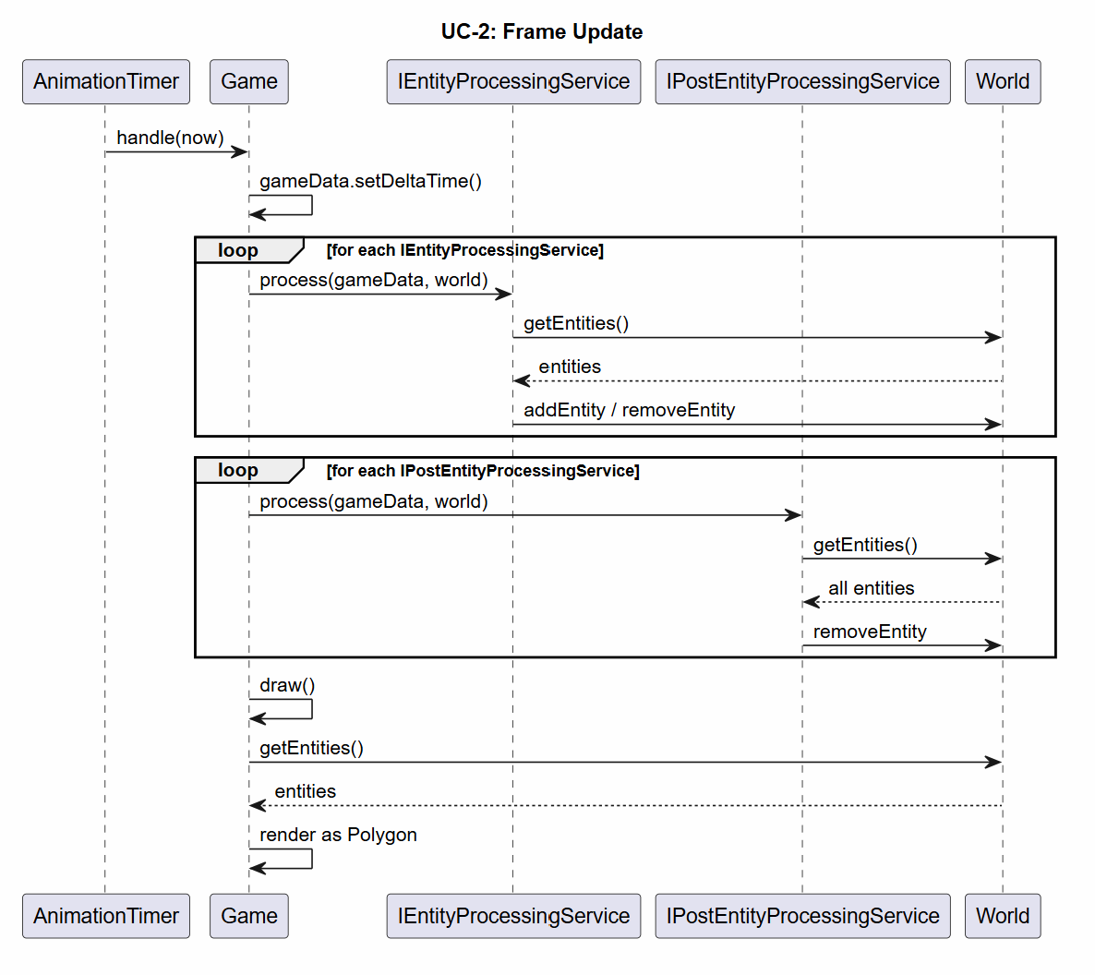
Figure 1 Sequence diagram UC-2

UC-3: Component Removal
A component module is removed from the module path. On the next startup the ServiceLoader discovers one less provider for the relevant SPIs. The orchestrator initializes normally but the missing component’s entities are never added to World, and its processing logic is never called. No other component requires modification.

Design
The component structure of the system is shown in Figure 2. The four-layer architecture is described in detail in the Module Architecture section below. At the highest level we have Common that defines the shared data types, six plugin modules provide the game behavior through SPIs and Core sits at the bottom discovering and assembling them at runtime via ServiceLoader.
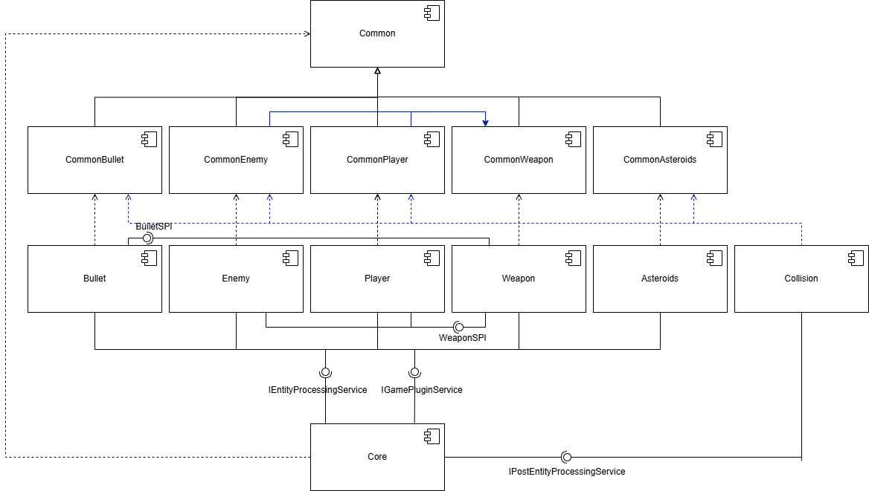
Figure 2 Component Diagram
The diagram illustrates two kinds of interface relationships. Provided interfaces are shown as lollipops, indicating that the attached component implements and exports that interface. Required interfaces are shown as sockets which indicates that the component depends on another module to fulfil it. The WeaponSPI lollipop on Weapon connects to sockets on both Player and Enemy meaning that both components acquire a weapon at runtime without depending on the Weapon module directly. The BulletSPI lollipop on Bullet connects to a socket on Weapon, which allows the weapon system to create bullets without a compile-time dependency on the bullet module.

Module Architecture
The system is organized into four layers, each depending on a layer below it:
Layer | Modules | Role
0 - Infrastructure | Common | Exports service interfaces, GameData, World and entity base class
1 - Entity Interfaces | CommonPlayer, CommonEnemy, CommonAsteroids, CommonBullet, CommonWeapon | Exports concrete entity types for use by component and collision modules.
2 – Components | Player, Enemy, Asteroid, Bullet, Weapon, Collision | Implements SPIs and provides game behaviour
3 – Orchestrator | Core | Discovers and assembles components via ServiceLoader and Spring
Table 4 Layered Architecture
All dependency arrows point downward. No module layer N depends on a module above, preventing circular dependencies. Component modules (Layer 2) have no compile-time knowledge of each other, except CommonPlayer and CommonEnemy which knows about CommonWeapon, their only shared dependency is the Common and entity interface modules.

Service Provider Architecture
Each component module declares its service provisions in its module-info.java file using the provides keyword. The orchestrator declares its consumption of each SPI using the uses keyword. This arrangement means the complete set of active components is determined at module-path assembly time, not at compile time.
The system defines five service interfaces across two categories:
- Core SPIs which are declared in Common: IGamePluginService, IEntityProcessingService, IPostEntityProcessingService.
- Custom SPIs which are declared in the entity interface modules: BulletSPI and WeaponSPI.
Custom SPIs allow components such as Player and Enemy to obtain bullets and weapons without depending on the Bullet or Weapon implementation modules, they depend only on the interface-level modules.

JPMS Module Declarations
Strong encapsulation is enforced through explicit export declarations. Component implementation classes are not exported, only the SPIs and entity types that form the public API of each module are accessible to other modules. The following snippet illustrates the pattern for the player module:
module Player {
requires Common;
requires CommonPlayer;
requires CommonWeapon;
requires java.desktop;
requires javafx.graphics;
requires CommonBullet;
exports dk.sdu.mmmi.cbse.Playersystem;
uses dk.sdu.mmmi.cbse.common.bullet.BulletSPI;
uses dk.sdu.cbse.common.weapon.WeaponSPI;
provides dk.sdu.mmmi.cbse.common.services.IGamePluginService with dk.sdu.mmmi.cbse.Playersystem.PlayerPlugin;
provides dk.sdu.mmmi.cbse.common.services.IEntityProcessingService with dk.sdu.mmmi.cbse.Playersystem.PlayerControlSystem;
}
Figure 3 Module Player code snippet
The Player module exports its system package so that the service provider implementations are accessible to the ServiceLoader at runtime. Encapsulation is still enforced at the component level and only the declared package is visible to other modules and no other module in the system declares a requires Player dependency. The PlayerPlugin and PlayerControlSystem classes are therefore unreachable in practice.

Spring Integration
The Core module uses Spring’s AnnotationConfigApplicationContext to manage the game orchestrator bean. The Game class receives its service collections via dependency injection. The module-info.java for Core declares:
opens dk.sdu.mmmi.cbse.main to javafx.graphics,spring.core;
Figure 4 Spring
This opens declaration grants Spring the reflection access it requires for dependency injection while restricting that access to spring.core specifically. No other module can reflectively access the Core implementation classes.

Component Contracts Summary
Interface | Providers | Pre-condition | Post-condition
IGamePluginService | Player, Enemy, Asteroid, Bullet & Weapon | World initialized | Entities registered in world
IEntityProcessingService | Player, Enemy, Asteroid, Bullet & Weapon | deltaTime > 0 | Entity state updated for frames
IPostEntityProcessingService | Collision | All entity processors complete | Cross-component state resolved
BulletSPI | Bullet | Firing entity exists in World | New bullet entity added to World
WeaponSPI | Weapon | Owner entity exists | Weapon entity added to world.
Table 5 Component Contracts

Implementation
The implementation documents how the component architecture is realized in code, how components are registered and accessed at runtime, and how reliable dependencies and strong encapsulation are enforced by JPMS

Component Registration via ServiceLoader
Components register themselves through module-info.java declarations alone. There is no central plugin registry and no runtime configuration file. At startup, Core loads each SPI once and caches the result for the session:
class ModuleConfig {
@Bean
public Game game(){
return new Game(gamePluginServices(), entityProcessingServiceList(), postEntityProcessingServices());
}
@Bean
public List<IEntityProcessingService> entityProcessingServiceList(){
return ServiceLoader.load(IEntityProcessingService.class).stream().map(ServiceLoader.Provider::get).collect(toList());
}
@Bean
public List<IGamePluginService> gamePluginServices() {
return ServiceLoader.load(IGamePluginService.class).stream().map(ServiceLoader.Provider::get).collect(toList());
}
@Bean
public List<IPostEntityProcessingService> postEntityProcessingServices() {
return ServiceLoader.load(IPostEntityProcessingService.class).stream().map(ServiceLoader.Provider::get).collect(toList());
}
}

Figure 5 Module Config Code Snippet
The ServiceLoader returns all implementations whose modules declare a matching provides clause. The ordering is non-deterministic across modules, which is acceptable because components communicate only through shared data structure rather than through ordered invocation contracts.

Enforcing Dependencies and Encapsulation
Reliable dependencies are enforced at the module level by the requires keyword. Every module declares all of its external dependencies explicitly. There are no implicit classpath dependencies. If a required module is missing, the JVM will refuse to start and report the missing module. This eliminates the class-path dependency ambiguity known as “jar hell”.
Strong encapsulation is enforced by the exports keyword. Implementation classes are not exported from component modules. The only accessible types are those in the Common modules and the minimal public API of each component. Because PlayerPlugin and PlayerControlSystem are not exported from the Player module, no other module can reference them directly, even if it places the player JAR on its module path.

Component Implementations

Core
The Core module is the only orchestrator. The Game class initializes the spring application context, loads all service providers via ServiceLoader, and drives the game loop using a JavaFX AnimationTimer. The animation timer calls update() to compute the delta time, then invokes every IEntityProcessingService in sequence and finally invokes every IPostEntityProcessingService. After processing the draw() method iterates all entities in World and renders each one as a JavaFX Polygon. The spring context is used to inject the service collections into the Game bean, bridging the ServiceLoader discovery mechanism with the spring component model.
The ModuleConfig class above shows both the ServiceLoader discovery and the Spring bean declarations. Each @Bean method calls ServiceLoader.load() for one SPI and returns the result as a spring-managed list. The Game bean receives all three lists via constructor injection which bridges the two frameworks.

Player
The PlayerPlugin creates a single player entity at the screen centre with a triangular polygon. The player has a move speed of 200 units per second and a turn speed of 250 degrees per second. The PlayerControlSystem reads the current key state from GameData each frame. The LEFT and RIGHT or A and D keys rotate the ship. The UP or W key applies thrust in the direction the ship is facing and SPACE fires the weapon. Movement is clamped to the screen boundaries so the player always remains visible. Weapon creation is delegated to the WeaponSPI, which the Player module discovers via ServiceLoader. The player module never imports the weapon implementation module.
public class PlayerPlugin implements IGamePluginService {
private Entity player;
@Override
public void start(GameData gameData, World world) {
player = createPlayerShip(gameData);
world.addEntity(player);
}
private Entity createPlayerShip(GameData gameData) {
Entity playerShip = new Player();
playerShip.setPolygonCoordinates(-5,-5,10,0,-5,5);
playerShip.setX(gameData.getDisplayWidth()/2.0);
playerShip.setY(gameData.getDisplayHeight()/2.0);
playerShip.setRadius(10);
playerShip.setHealth(3);
playerShip.setColor(Color.BLUE);
playerShip.setMoveSpeed(200);
playerShip.setTurnSpeed(250);
return playerShip;
}
@Override
public void stop(GameData gameData, World world) {
world.removeEntity(player);
}
}

Figure 6 PlayerPlugin

Enemy
The EnemyPlugin spawns two initial enemy entities at a random position. The EnemyControlSystem spawns additional enemies at a rate of one every twenty seconds. Each enemy moves forward continuously and applies a small random rotation jitter each frame chosen from the interval [-2, +2] multiplied by the turn speed and delta time, to produce autonomous wandering behavior. When an enemy reaches a screen edge, it teleports to the opposite edge (Wraparound). The enemy fires continuously using the WeaponSPI at a fire rate of 1.0.
public class EnemyControlSystem implements IEntityProcessingService {
private final Random rand = new Random();
private final EnemyPlugin enemyPlugin = new EnemyPlugin();
private final ServiceLoader<WeaponSPI> weaponLoader = ServiceLoader.load(WeaponSPI.class);
private static final double SPAWN_RATE = 20;
private double spawnTimer = 10;
@Override
public void process(GameData gameData, World world) {
spawnTimer += gameData.getDeltaTime();
if (spawnTimer >= SPAWN_RATE) {
spawnTimer -= SPAWN_RATE;
world.addEntity(enemyPlugin.createEnemy(gameData));
}
for (Entity entity : world.getEntities(Enemy.class)) {
Enemy enemy = (Enemy) entity;
if (enemy.getHealth() <= 0) {
world.removeEntity(enemy);
continue;
}
if (enemy.getWeapon() != null) {
enemy.getWeapon().setIsShooting(true);
} else {
weaponLoader.stream().map(ServiceLoader.Provider::get).findFirst().ifPresent(spi -> {
enemy.setWeapon(spi.createWeapon(enemy));
enemy.getWeapon().setFireRate(1);
world.addEntity(enemy.getWeapon());
});
}
double changeX = Math.cos(Math.toRadians(enemy.getRotation()));
double changeY = Math.sin(Math.toRadians(enemy.getRotation()));
int direction = rand.nextInt(5) - 2;
enemy.setRotation(enemy.getRotation() + direction * enemy.getTurnSpeed() * gameData.getDeltaTime());
//Wraparound in all four edges
enemy.setX(enemy.getX() + changeX * enemy.getMoveSpeed() * gameData.getDeltaTime());
enemy.setY(enemy.getY() + changeY * enemy.getMoveSpeed() * gameData.getDeltaTime());
if (enemy.getX() < 0) {
enemy.setX(enemy.getX() + gameData.getDisplayWidth());
}
if (enemy.getX() > gameData.getDisplayWidth()) {
enemy.setX(enemy.getX() % gameData.getDisplayWidth());
}
if (enemy.getY() < 0) {
enemy.setY(enemy.getY() + gameData.getDisplayHeight());
}
if (enemy.getY() > gameData.getDisplayHeight()) {
enemy.setY(enemy.getY() % gameData.getDisplayHeight());
}
}
}
}

Figure 7 EnemyControlSystem

Asteroid
The AsteroidPlugin spawns one initial asteroid at the beginning. The AsteroidControlSystem spawns new asteroids every five seconds at random screen positions. Asteroids move in a fixed direction determined at spawn time and wrap around screen edges. When the CollisionDetector marks an asteroid as hit by setting its isHit flag, the AsteroidControlSystem invokes the AsteroidSplitter, which removes the original asteroid and adds two fragments. Each fragment is rotated +-35 degrees from the original heading and has its radius reduced by one unit and retains the original health value. When an asteroid’s health reaches zero it is removed without splitting.

Bullet
The BulletPlugin initializes the bullet subsystem. The BulletControlSystem implements both IEntityProcessingService and BulletSPI. As an entity processor it moves every bullet forward at 600 units per second in the direction of the bullet’s rotation and removes any bullet that exits the screen boundaries. The BulletSPI factory creates a new bullet entity positioned ten units ahead of the shooter, inheriting the shooter’s rotation.

Weapon
The WeaponPlugin initializes the weapon subsystem. The WeaponControlSystem implements both IEntityProcessingService and WeaponSPI. The WeaponSPI factory creates weapon entities for requesting components. As an entity processor, it evaluates the firing state of each weapon entity each frame. If a weapon is in shooting mode and its fire cooldown has elapsed, it requests a bullet from the BulletSPI and resets the cooldown. The fire cooldown is calculated as 1.0/fireRate.
public class WeaponControlSystem implements IEntityProcessingService, WeaponSPI {
private final ServiceLoader<BulletSPI> bulletLoader = ServiceLoader.load(BulletSPI.class);
@Override
public void process(GameData gameData, World world) {
for (Entity entity : world.getEntities(Weapon.class)) {
Weapon weapon = (Weapon) entity;
weapon.setFireCooldown(weapon.getFireCooldown() + gameData.getDeltaTime());
if (weapon.canShoot()) {
if (weapon.getIsShooting()) {
bulletLoader.stream().map(ServiceLoader.Provider::get).findFirst().ifPresent(
spi -> world.addEntity(spi.createBullet(weapon.getOwner(), gameData)));
weapon.setFireCooldown(0);
}
}
weapon.setIsShooting(false);
}
}
@Override
public Weapon createWeapon(Entity owner) {
return new Weapon(owner);
}
}

Figure 8 WeaponControlSystem

Collision
The CollisionDetector implements IPostEntityProcessingService. It runs after all entity processors have updated positions for the frame. It iterates all entity pairs and computes the distance between their positions. If the distance is less than the sum of their radii, a collision is recorded. The following rules apply:
- If Asteroid hits Player: Player health is set to zero immediately.
- If Enemy hits Player: Player health is set to zero immediately.
- If Player bullet hits Asteroid: Asteroid health is decremented by one, the asteroid is marked as hit and the bullet is removed.
- If Player bullet hits Enemy: Enemy health is decremented by one and the bullet is removed.
- If Enemy bullet hits Player: Player health is decremented by one and the bullet is removed.
The collision module depends on all five Common entity modules so that it can perform instanceof checks. It does not depend on any component implementation module.

Spring Boot Microservice
The ScoreService is a standalone Spring Boot microservice that tracks the player’s score independently of the game process. It exposes two HTTP endpoints on localhost:8080: a GET/score endpoint that returns the current score as an integer and a POST/score endpoint that increments the score by a given value and returns the updated total. The service is implemented as a single @RestController bean with an AtomicInteger field which ensures thread-safe increments under concurrent requests. It requires no external infrastructure to start, the “mvn spring-boot:run” from the ScoreService directory is sufficient.
This module demonstrates the microservice principle of process isolation. The ScoreService has no compile-time dependency on any AsteroidsFX module and no shared state with the game process. The score is maintained in memory and resets on restart, which is acceptable for demo context. A fully functional deployment would add a persistent storage and expose the service behind an API.

Shared World Communication Pattern
This pattern is the fundamental communication mechanism in the system. Components do not call each other directly, instead every component reads from and writes to the shared World object, which the Core orchestrator manages and passes to each service call. At the implementation level this is realized through the typed World.getEntities(Class) lookup. Each component calls this method with its own entity type, which means that the Player module only ever sees Player entities, the Enemy module only sees Enemy entities and so on. No component can accidentally process another component’s entities. As a result of this, adding a new component type requires only implementing the relevant SPIs and placing the new module on the module path.

Test
The system is validated at two levels, unit tests that target individual component logic in isolation and integration validation through deployment of the complete game on the component container.

Unit Tests
The project uses Junit tests across two component modules. The tests target pieces of logic that are deterministic and can be verified without launching the full JavaFX game window.

CollisionDetectorTest
Located in Collision/src/test/java, this test exercises the CollisionDetector.collides() method directly using minimal Entity objects with controlled positions and radii. Three cases are verified:
- Two entities whose bounding circles overlap are reported as colliding.
- Two entities whose bounding circles touch exactly at the edge are reported as not colliding
- Two entities that are clearly separated are reported as not colliding.
The test is self-contained because the collision predicate is a pure distance calculation requiring no game loop context. To make the test accessible under JPMS, the collision module exports its implementation package to the test runner.
public class CollisionDetectorTest extends TestCase {
private CollisionDetector detector;
@Override
protected void setUp() { detector = new CollisionDetector(); }
public void testCollidesWhenEntitiesOverlap() {
Entity entity1 = createEntity(10.0, 10.0, 5.0f);
Entity entity2 = createEntity(14.0, 13.0, 5.0f);
assertTrue(detector.collides(entity1, entity2));
}
public void testCollidesWhenEntitiesTouchExactlyAtEdge() {
Entity entity1 = createEntity(0.0, 0.0, 5.0f);
Entity entity2 = createEntity(10.0, 0.0, 5.0f);
assertFalse(detector.collides(entity1, entity2));
}
public void testDoesNotCollideWhenEntitiesAreSeparated() {
Entity entity1 = createEntity(0.0, 0.0, 5.0f);
Entity entity2 = createEntity(20.0, 20.0, 5.0f);
assertFalse(detector.collides(entity1, entity2));
}
private Entity createEntity(double x, double y, float radius) {
Entity entity = new Entity();
entity.setX(x);
entity.setY(y);
entity.setRadius(radius);
return entity;
}
}

Figure 9 Collision Test

PlayerControlSystemTest
Located in the Player/src/test/java, this one tests the movement logic in PlayerControlSystem.process(). The test constructs a player entity with rotation set to 0 degrees and then simulates a single UP key press in a minimal GameData object and calls process() with a fixed delta time. The post-conditions verified are:
- The players X position has increased (forward movement along the X axis at 0 degrees rotation).
- The Players Y position is unchanged.
The movement formula is deterministic given rotation, speed and delta time. As with the collision test, the Player module exports its implementation package for test access.
public class PlayerControlSystemTest extends TestCase {
private PlayerControlSystem system;
private GameData gameData;
private World world;
private Player player;
@Override
protected void setUp() {
system = new PlayerControlSystem();
gameData = new GameData();
world = new World();
player = new Player();
gameData.setDisplayWidth(2000);
gameData.setDisplayHeight(2000);
gameData.getKeys().setKey(GameKeys.UP, true);
player.setX(100.0);
player.setY(200.0);
player.setRotation(0.0);
player.setMoveSpeed(100);
player.setHealth(1);
player.setTurnSpeed(250);
world.addEntity(player);
}
public void testPlayerMovesForwardWhenUpIsPressed() {
// Prime deltaTime using the public API so the test stays JPMS-friendly.
gameData.setDeltaTime();
try {
Thread.sleep(20L);
} catch (InterruptedException e) {
Thread.currentThread().interrupt();
throw new AssertionError("Test interrupted while waiting for delta time", e);
}
gameData.setDeltaTime();
system.process(gameData, world);
assertTrue(player.getX() > 100.0);
assertEquals(200.0, player.getY(), 0.0001);
}
}

Figure 10 Player test

Integration Validation
The full system is validated by building and running the complete game. The ServiceLoader discovers all thirteen module-info.java declarations and loads the thirteen service providers at startup. The game window opens, all five plugin start() methods are invoked and the game loop begins at approximately 60 frames per second. Integration is confirmed when all the following are observable in the running game:
- The player ship responds to keyboard input.
- Enemy ships spawn autonomously and move across the screen.
- Asteroids spawn and drift in fixed directions.
- SPACE fires a bullet that travels forward and exits the screen.
- Player bullets damage and split asteroids.
- Player bullets remove enemies.
- Asteroid and enemy collisions with the player end the game.
The component removal scenario (NF-2) can be validated by removing modules from the build, i.e. the Collision module. The game starts successfully, entities move normally and no exceptions are thrown. This confirms that no module has a compile-time dependency on each other.
The removal of components is demonstrated in the project demo. Here most of the plugin components are removed. The demonstration of the component removal is available at [1]

Build and test verification
The test results are captured in Figure 11 and shows the Maven build output confirming that both test suites pass. All CollisionDetectorTest cases and the PlayerControlSystemTest cases execute successfully with no failure. Figure 12 shows the running game, confirming that the integration validation criteria listed above are met. The player ship is visible and responds to input. The enemy ships and asteroids are present on screen and the game loop is running at the expected frame rate.
The component removal scenario described in NF-2 is validated by building the project with the Collision module excluded from the module path. The game starts without exceptions and all components initialize normally and entities move freely.
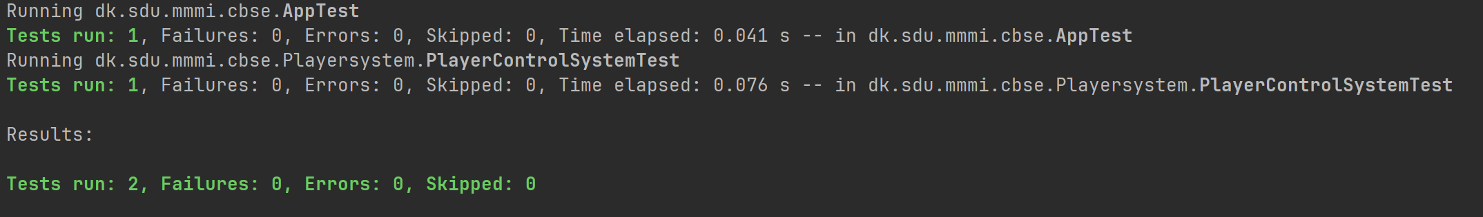
Figure 11 Maven build confirm
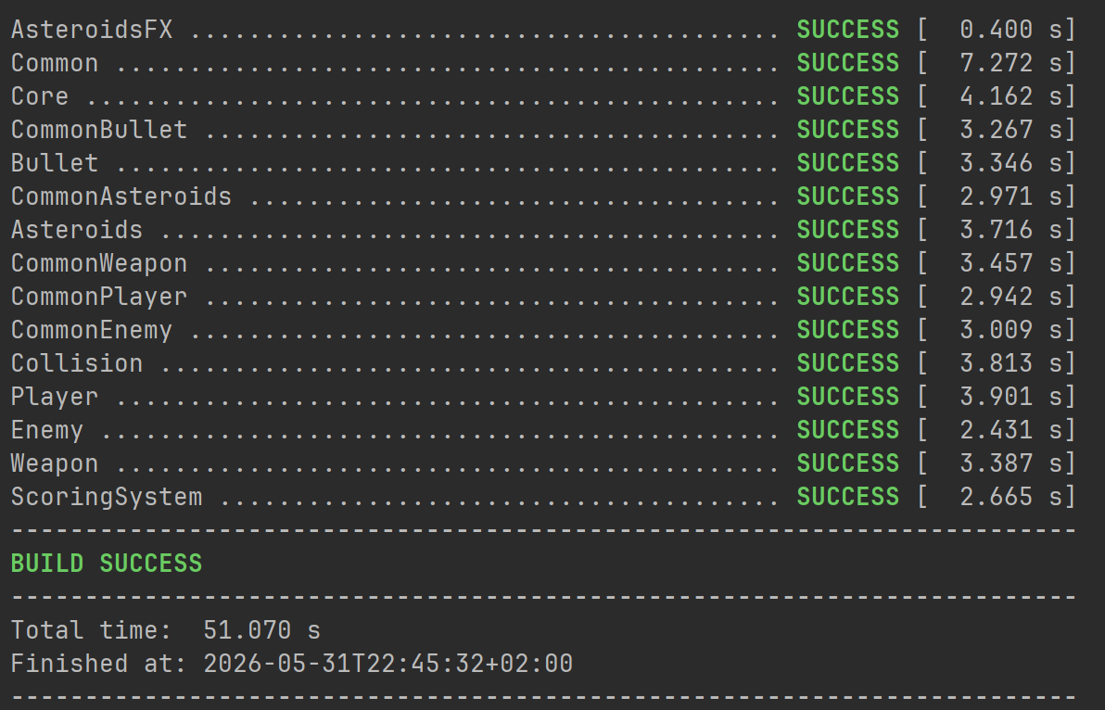
Figure 12 Running game

Discussion
AsteroidsFX demonstrates that component-oriented design backed by JPMS, ServiceLoader and spring can effectively solve the core problem of runtime composability and unintended coupling identified in the analysis phase.

Composability
The requirement that a component can be removed without recompilation (NF-2) is fully met. Removing the modules confirmed that the orchestrator and all remaining components continued to function without modification. Adding a new component type to the game requires only that you create a new module that implements IGamePluginService and IEntityProcessingService and adds it to the module path. The existing codebase would not require any changes.

Encapsulation
The JPMS exports mechanism can enforce encapsulation at the language level. This is stronger than the conventional access modifier approach. An implementation class in the Player module cannot be imported from any other module regardless of its java visibility modifier. This makes the architectural boundaries non-negotiable and prevents the general weakening of component boundaries that is common in large codebases.

Design Trade-offs
The communication model where all interaction passes through the shared World object, is effective for decoupling but places the entire inter-component contract burden on the entity types. The Collision module must know all entity types to perform collision resolution. This means that adding a new entity type that participates in collisions requires modifying the Collision module. A more advanced design would introduce some sort of a collision-tagging mechanism which allows a new entity type to participate without modifying the collision component.
The Spring context in Core uses reflection which requires the opens directive. The decision taken follows the principle of minimal reflection access and correctly limits the surface area exposed to the framework.

Requirements Coverage
All functional requirements P-1 and all the way through C-1 are met by the implemented components. All non-functional requirements are also met, NF-1 and NF-2 are met by the ServiceLoader and JPMS module path design. NF-3 is achieved by structuring the system's dependencies within a layered architectural model which strictly prohibits circular dependencies between modules. NF-4 is met by the incorporation of JPMS, ServiceLoader, Spring and unit tests. NF-5 is met by the targeted opens directive and NF-6 is met by the JavaFX AnimationTimer.

Conclusion
This report has described the requirements, analysis, design, implementation and testing of AsteroidsFX. The system is structured across thirteen JPMS modules organized in four dependency layers which are the Common infrastructure module, five entity interface modules, six component implementation modules and the Core orchestrator. Component discovery and assembly are performed at runtime by the ServiceLoader API and driven by provides and uses declarations in each module-info.java file. Spring provides dependency injection in the orchestration layer. Two unit tests and an integration run confirm that the system behaves correctly.
The primary contribution of this architecture is that component substitution requires no recompilation of any existing modules. The system has achieved runtime composability. If you for example remove the Collision module, it leaves all the remaining modules functional. A new component type can also be introduced purely by adding a new module to the module path. The JPMS exports mechanism provides strong encapsulation enforced by the language runtime rather than by convention.

References

[1] | O. Thomsen, "Youtube," 4 june 2026. [Online]. Available: https://youtu.be/T7N9Ujm_5sY.
[2] | N. Parlog, in The Java Module System, Manning publications, 2019, p. 404.

